**When on GTP**

**POINTS**

* Every week AMG reviews the status of GTP associates.
* When on GTP the associate has to comply to the following:
  + Submit weekly status report in InfoBiz **before 5:00 PM IST every Friday**
  + Reach out to the Service Line Lead and get activities assigned
  + Spend more than 50% of time in training
  + Ensure that post on YAMMER – “What do when on GTP” is read
  + Become part of the GTP group on Yammer
* Communicate leave plan with AMG & Service Line Lead for approval (2 weeks in advance – if any)
* Ensure 100% timesheet compliance

**How to submit WSR in system**

1. Login to [InfoBiz](mailto:https://infobiz.infocepts.com/%23/) 🡪Timesheet 🡪 GTP WSR

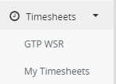

1. Select Month 🡪 Select Week 🡪 Add row 🡪 Fill in the WSR in ‘Activities’ column for respective dates 🡪Save

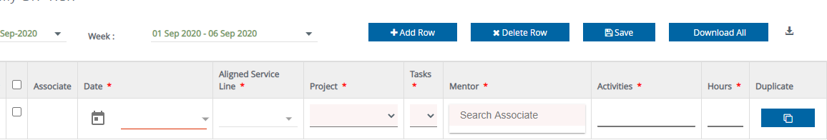

1. Mentor aligned by your respective Service Line Lead.
2. Select appropriate task given in the drop down list.

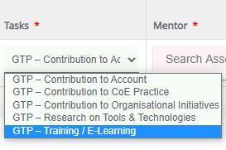

**How to submit timecards on GTP**

Step 1: **Go to InfoBiz**

Step 2: **Click on Timesheet tab 🡪 My Timesheets**

Step 3: **Add Task**

Step 4: **Show Generic Task**

Step 5: **Search for GTP task under Core Delivery – GTP**

1. *GTP – Contribution to CoE Practice*
2. *GTP – Contribution to Organisational Initiatives*
3. *GTP – Research on Tools & Technologies*
4. *GTP – Training / E-Learning*
5. *GTP – Contribution to Account*

Step 6: **Add any of the GTP Task**

Step 7: **Book your time against selected GTP task**

**List of CoE and respective Leads**

|  |  |
| --- | --- |
| **CoE Lead** | **Skill / Service Line** |
| Nilima Mehtre | Modern Analytics |
| R V Prakash | Cloud & Platform Development |
| Hiresh Dandekar | Managed Services |
| Sanchita Adhya | Data Management |
| Madhur Shah | Custom Development |